

**FOUNDATION IN SCIENCE & TECHNOLOGY**

**COURSEWORK COVER SHEET**

**SUBJECT TITLE : BASIC COMPUTER CONCEPT**

**SUBJECT CODE : FSTM3054**

**INTAKE : JULY 2020**

**SEMESTER : 1**

**COURSEWORK TITLE : REVIEW 2 – DATABASE PROJECT**

**COURSEWORK** **:** **20%**

The objective of this assessment is:

* To design a relational database in Microsoft Access.
* To apply the use of SQL in relational database.

Instructions:

* Submit both hardcopy and softcopy of your assignment.
* Please include a cover page, table of contents and references in your assignment.

**Group Members: -** Daniel Alexander Gomes

- Hoo Kai Seng

- Lew Kai Ern

- Lester Koon Zhy Min

Table of Contents

*TASK 1: Requirements Report* 3

1.1: INTRODUCTION 3

1.2: BUSINESS RULES AND RELATIONSHIP 4

1.3: IDENTIFY ENTITIES AND ATTRIBUTES 6

*TASK 2: Data Modelling* 7

2.1: ENTITY RELATIONSHIP DIAGRAM (ERD) 7

2.2: DATA DICTIONARY 8

*TASK 3: Creating The Database* 15

3.1: CREATE AND POPULATE THE TABLES 15

3.2: ESTABLISHING THE RELATIONSHIP 21

3.3: CREATE FORMS 22

*TASK 4: Creating SQL Queries* 23

4.1: CREATE SQL QUERIES 23

*TASK 5: Contribution Evaluation* 28

*TASK 1: Requirements Report*

1.1: INTRODUCTION

With the rapid development of information industry, information management has been introduced and applied to various industry management fields. High speed network information constantly changes and affects people's values and lifestyle. For an enterprise, the biggest task is to strive for the greatest interests, which requires improving the management level of the enterprise. It is necessary to design a database management system suitable for the enterprise. The database management system designed by us is aimed at the database management system of the cybercafe. It has a more comprehensive consideration for the management level of the cybercafe. It is very helpful to improve the management of the cybercafe, accelerate the pace of management, improve the competitiveness and strive for greater economic benefits.

Therefore, in order to enhance the competitiveness of enterprises, it is necessary to vigorously promote the construction of enterprise informatization, and use the advanced office automation system to realize the internal information management, sharing and exchange of enterprises, so as to make enterprises obtain the first opportunity in the fierce competition in the 21st century. With the rapid development of the network, the network is integrated into every corner of our life, cybercafe have become more and more popular industry, in order to meet the needs of the market and improve the management ability of cybercafe, it is necessary to adjust the database management system of cybercafe to improve work efficiency. The management of cybercafe is an indispensable link in the management of a cybercafe. Designing a better system can help to improve the working efficiency and competitiveness of the cybercafe management, strive for the maximum benefits in the shortest time, and provide great convenience for the managers.

“Ah Chong’s Cyber Bar” begun its operations in the early 2018 as a small start-up business venturing in the industry of fully dedicated internet-access business, or cybercafés for short. Over the past two years, the business of “Ah Chong’s Cyber Bar” have stabilized and even expanded into multiple branches across the country. There was previously an absence of a database in the management of the company and all of its records and information was stored manually in files and folders. This method of upkeep of the management system which was used at the start of the company operations became increasingly inefficient and untenable with ever-growing amount of data being dealt with. For an enterprise, the biggest task is to strive for the greatest interests, which requires improving the management level of the enterprise. It is necessary to design a database management system suitable for the business to help improve the management of the cybercafe, accelerate the pace of management, improve the competitiveness, and strive for greater economic benefits. Through this implementation of a database, “Ah Chong’s Cyber Bar” would be able to have solutions for previous encountered problems such as:

* Failure for effective backing up of manual files
* Losing track of files and records
* Wrongly billed payment
* Unable to keep track of finance
* Problems keeping track of computers that are available for use
* Management of records and data are too time consuming

1.2: BUSINESS RULES AND RELATIONSHIP

**Branches:**

* Each branch has a different branch number
* Each branch is in a different county and has a different area code (postcode)

**Staff:**

* Each stuff must at least be 18 years of age
* They need to fill up a registration form and provide details such as first name last name, age, and contact information.
* Each staff is given a unique ID
* Staff will either work a day shift or a night shift
* Each staff can work in one or more section
* Each staff can only work at one branch at a time.

**Admins:**

* Some staff are chosen to be admins
* Each admin is given a unique ID separate from their Staff ID
* An admin must have working experience as a normal staff for 3 or more years
* Each admin can only control and manage only one section

**Section:**

* Each section is given a unique name consisting of alphabets only
* Each section is controlled by one or more admins
* Each section must have at least one staff working in it
* Each Section will have one or more PCs

**PC:**

* Each PC has a different number
* Each PC can only be in one section
* There are multiple PCs in each section
* Login ID and password are required to use a PC
* Login ID must be between 8 to 16 characters and can consist of letters and numbers
* Each PC will have a different Login ID
* Password must be between must be between 4 to 14 characters and can consist of letters and numbers
* PCs may have the same password
* A PC can only be used by one customer at a time
* Each PC is either available or unavailable

**Customers:**

* Each customer must fill a form with details such as name, and age
* Filling up a contact number is optional
* Each customer has unique ID
* A customer must not be younger than 12 years.
* Each customer is limited for using only one PC at a time.
* Each customer is given a Login ID and Password to access the PCs for each session
* A customer may have more than one invoice billed

**Invoice:**

* Each transaction is given a unique invoice ID
* Each customer can have more than one invoice depending on the number of sessions
* Each invoice can only be billed to one customer
* The invoice records the time length of each session
* Each session cannot be longer than 6 hours
* Amount of invoice is based on the hourly fee
* Invoice can be given through payment by cash, credit card or debit card.
* All invoices will have a date and time stamp

1.3: IDENTIFY ENTITIES AND ATTRIBUTES

|  |  |  |
| --- | --- | --- |
| **Entity** | **Description** | **Attributes** |
| BRANCHES | Data about various branches | BranchNo, AreaCode, Location |
| STAFF | Data related to the company’s staff | StaffID, SFirst_Name, SLast_Name, S_Age, S_ContactNo, BranchNo, Shifts, SectionName, Admin |
| ADMIN | Data related to the admins | AdminID, StaffID, Staff_Name, SectionName, Workexperience |
| SECTION | Data about the sections in each branch | SectionName, AdminID, NoOfPC, NoOfStaff, BranchNo |
| PC | Data related to each PC | PCNumber, LoginID, Password, Availability, SectionName |
| CUSTOMER | Data related to the customers | CustomerID, FullName, C_Age, Cust_ContactNo, LoginID, Password, PCNumber |
| INVOICE | Invoice details | InvoiceID, CustomerID, TypeOfPayment, SessionTime, InvoiceDate, Time, TotalAmount |

*TASK 2: Data Modelling*

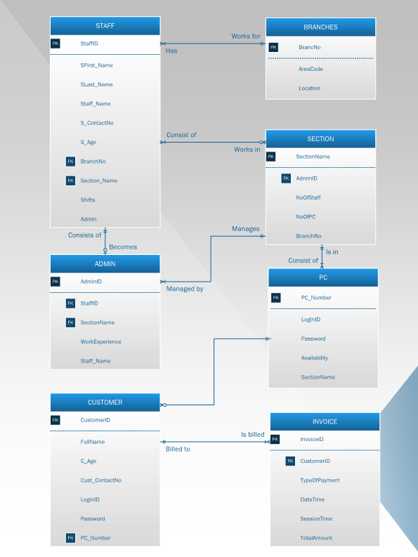2.1: ENTITY RELATIONSHIP DIAGRAM (ERD)

2.2: DATA DICTIONARY

**BRANCHES**

|  |  |  |  |
| --- | --- | --- | --- |
| **Field Name** | **Data Type** | **Size** | **Description** |
| BranchNo | Short Text | 2 | It is the branch number and acts as the primary key of the table. It follows the input mask ‘90;;#'. It is a required field and cannot be left null. |
| AreaCode | Short Text | 5 | The area code of the branch. It follows the input mask ‘00000;;#'. It is a required field and cannot be left null. |
| Location | Short Text | 20 | Indicates the location that the branch is located in. It is a required field and cannot be left null. |

**STAFF**

|  |  |  |  |
| --- | --- | --- | --- |
| **Field Name** | **Data Type** | **Size** | **Description** |
| StaffID | AutoNumber | Long integer | A unique number for each staff which also is the primary key of the table. It has only 3 digits with the format ‘000’. |
| SFirst_Name | Short Text | 50 | This attribute indicates the first name of the staff. It is a required field and cannot be left null |
| SLast_Name | Short Text | 50 | This attribute indicates the last name of the staff. It is a required field and cannot be left null. |
| S_Age | Number | Long integer | This attribute indicates the age of the staff. It follows the input mask ‘00;;* It also follows the validation rule ‘>=18’. It is a required field and cannot be left null. |
| S_ContactNo | Short Text | 11 | Indicates the contact number of the staff which consists of only 10 digits with a ‘-’ in between. It follows the input mask ‘000/-000/-0000;;*’. It is a required field and cannot be left null. |
| BranchNo | Short Text | 2 | The branch where the staff will be deployed, and it will also be the foreign key of the table. It follows the input mask ‘90;;#'. It is a required field and cannot be left null. |
| Shifts | Short text | 20 | This attribute indicates the shifts the staff is working in. It is a required field and cannot be left null. |
| SectionName | Short Text | 10 | Indicates which section the staff works in. It follows the input mask ‘L???????;;$’ It is a required field and cannot be left null. |
| Admin | Yes/No | - | Indicates whether the member of staff is an admin or not. It is a required field and cannot be left null. |

**ADMIN**

|  |  |  |  |
| --- | --- | --- | --- |
| **Field Name** | **Data Type** | **Size** | **Description** |
| AdminID | AutoNumber | Long integer | A unique number for each admin which also is the primary key of the table. It has only 2 digits with the format ‘00’. |
| StaffID | Number | Long  Integer | The unique StaffID of the admin. It is a foreign key in the table. It follows the format ‘000’. It is a required field and cannot be left null. |
| Staff_Name | Short Text | 100 | Indicates the name of the staff that is chosen to become an admin. It is a required field and cannot be left null. |
| SectionName | Short Text | 10 | Indicates which section the admin manages. It is a foreign key in the table. It follows the input mask ‘L???????;;$’ It is a required field and cannot be left null. |
| Workexperience | Number | Long  Integer | Indicates how many years of work experience the admin has. It follows the validation rule ‘>=3' with the caption Work_Xp |

**SECTION**

|  |  |  |  |
| --- | --- | --- | --- |
| **Field Name** | **Data Type** | **Size** | **Description** |
| SectionName | Short Text | 10 | It is the name of the section in each branch and acts as the primary key of the table. It follows the input mask ‘L???????;;$’ It is a required field and cannot be left null. |
| BranchNo | Short Text | 2 | Indicates the branch where the section is located in. It follows the input mask ‘90;;#'. It is a required field and cannot be left null. |
| AdminID | Short Text | 10 | This attribute indicates the admin that manages this section. It is a required field and cannot be left null. |
| NoOfPC | Number | Integer | Indicates the number of PCs in each section. It follows the validation rule ‘>0’. It is a required field and cannot be left null. |
| NoOfStaff | Number | Integer | Indicates the number of staff working in the section. It follows the validation rule ‘>0” It is a required field and cannot be left null. |

**PC**

|  |  |  |  |
| --- | --- | --- | --- |
| **Field Name** | **Data Type** | **Size** | **Description** |
| PCNumber | Auto number | Long  Integer | A unique number for each pc which is also the primary key of the table. It follows the format ‘0000’. It I a required field cannot be left null. |
| SectionName | Short Text | 10 | Indicates which section the PC is in. It follows the input mask ‘L???????;;$’ It is a required field and cannot be left null. |
| LoginID | Short text | 16 | Indicates the Login information for the computer. It is a foreign key in the table. It follows the input mask ‘AAAAAAAAaaaaaaaa;;#' It is a required field and cannot be left null. |
| Password | Short Text | 14 | Indicates the password used by the customer to use the computer. It follows the input mask ‘AAAAaaaaaaaaaa;;*' It is a required field and cannot be left null. |
| Availability | Short Text | 20 | Indicates whether the computer is available for use or unavailable. It is a required field and cannot be left null |

**CUSTOMER**

|  |  |  |  |
| --- | --- | --- | --- |
| **Field Name** | **Data Type** | **Size** | **Description** |
| CustomerID | Auto number | Long  integer | A unique number for each customer which is also the primary key of the table. It follows the format ‘000’. It is a required field and cannot be left null. |
| FullName | Short Text | 100 | Indicates the full name of the customer. It is a required field and cannot be left null |
| C_Age | Number | Long Integer | Indicates the age of the customer. It follows the input mask ‘00;;*' It follows the validation rule ‘>=12’. It is a required field and cannot be left null. |
| Cust_ContactNo | Short Text | 11 | Indicates the contact number of the customer. It follows the input mask ‘000/-000/-0000;;*’. It is not a required field and can be left null. |
| LoginID | Short Text | 16 | Indicates the login information currently in use by the customer to use a PC. It follows the input mask ‘AAAAAAAAaaaaaaaa;;#'. |
| Password | Short Text | 14 | Indicates the password currently in use by the customer to use the computer. It follows the input mask ‘AAAAaaaaaaaaaa;;*' |
| PCNumber | Number | Long Integer | The number for the PC that the customer is using. It is the foreign key of the table. It follows the format ‘0000’. |

**INVOICE**

|  |  |  |  |
| --- | --- | --- | --- |
| **Field Name** | **Data Type** | **Size** | **Description** |
| InvoiceID | Auto number | Long Integer | A unique key for each invoice which is also the primary key of the table. It is a primary key and cannot be left null |
| CustomerID | Number | Long integer | Indicates the ID of the customer the invoice is for. It follows the format ‘000’. It is a required field and cannot be left null. |
| TypeOfPayment | Short text | 20 | Indicates the method of payment that the customer will use to pay their bill. It is a required field and cannot be left null |
| SessionTime | Number | Long integer | Indicates how long the customer has been using the PC. It follows the validation rule ‘<=6’. It is a required field and cannot be left null. |
| InvoiceDate | Date/Time | - | Indicates the date of the invoice. It follows the format ‘General date’. It is a required field and cannot be left null. |
| Time | Date/Time | - | Indicates the time the invoice is issued. It follows the format ‘medium time’. It is a required field and cannot be left null. |
| TotalAmount | Currency | - | Indicates the total amount of money due by the customer. It follows the ‘currency’ format. It is a required field and cannot be left null |

*TASK 3: Creating The Database*

3.1: CREATE AND POPULATE THE TABLES

**Branches**

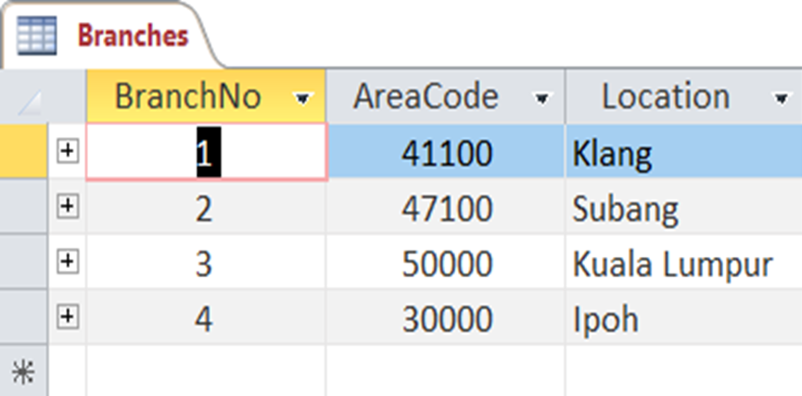

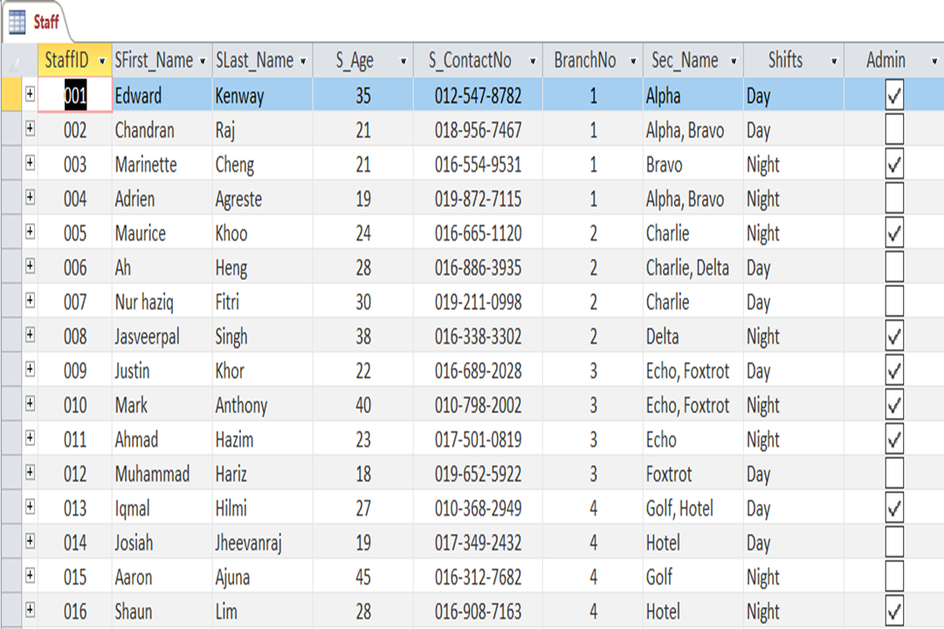**Staff**

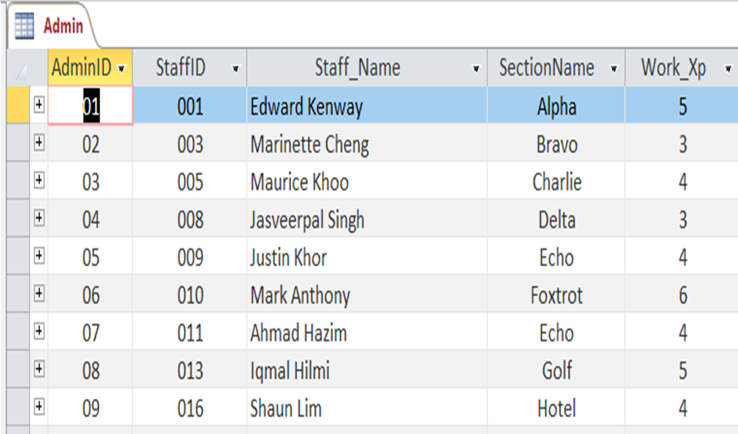**Admin**

**Section**

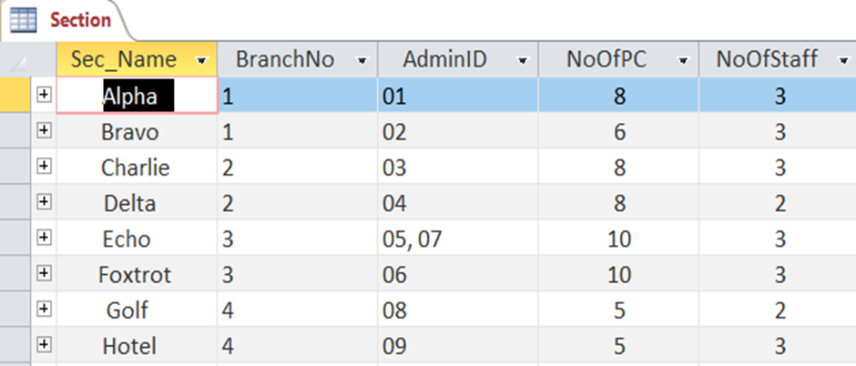

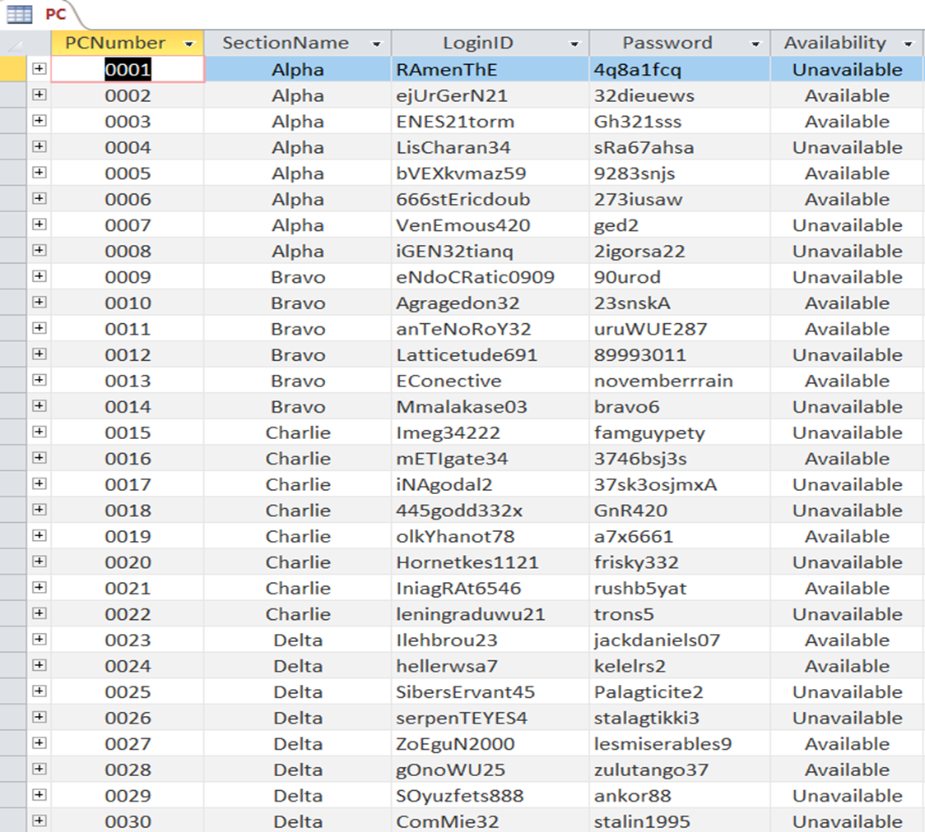**PC**

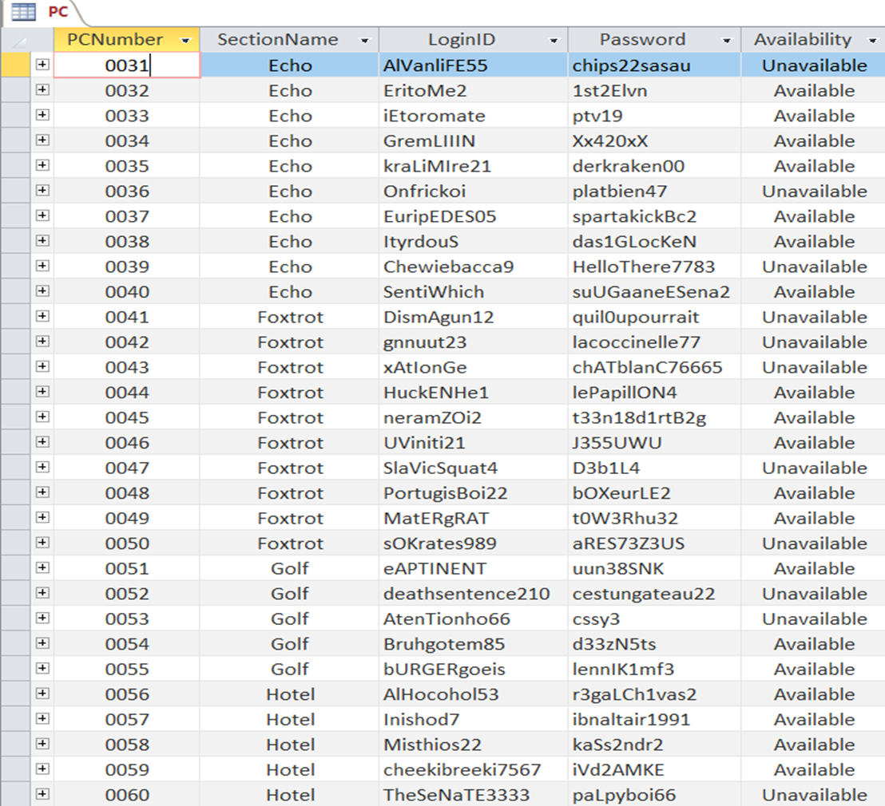

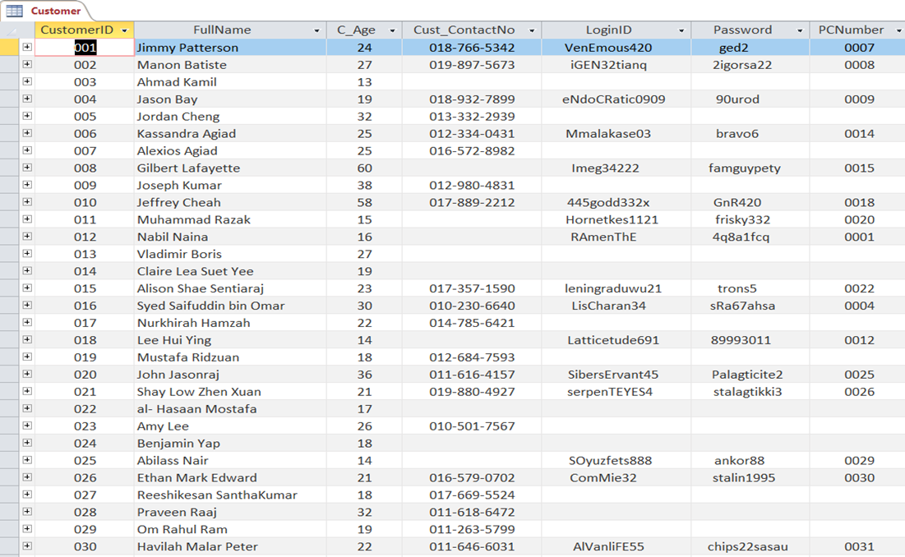**Customer**

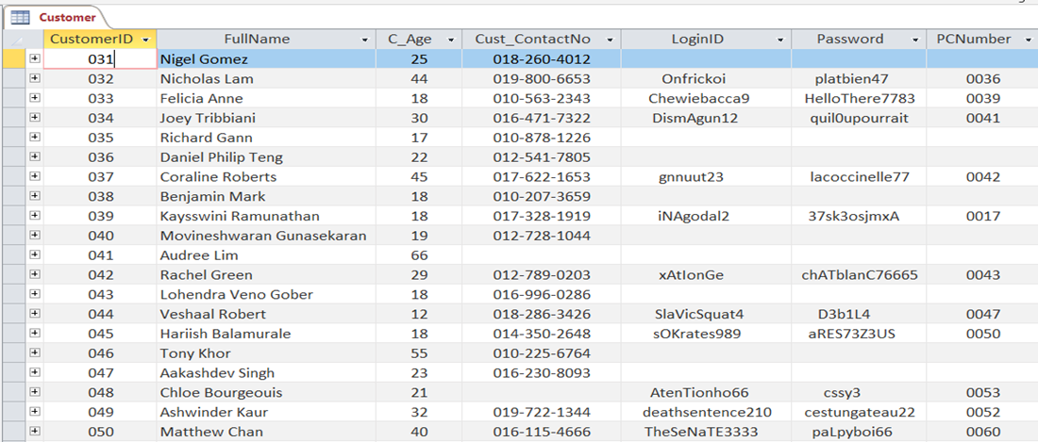

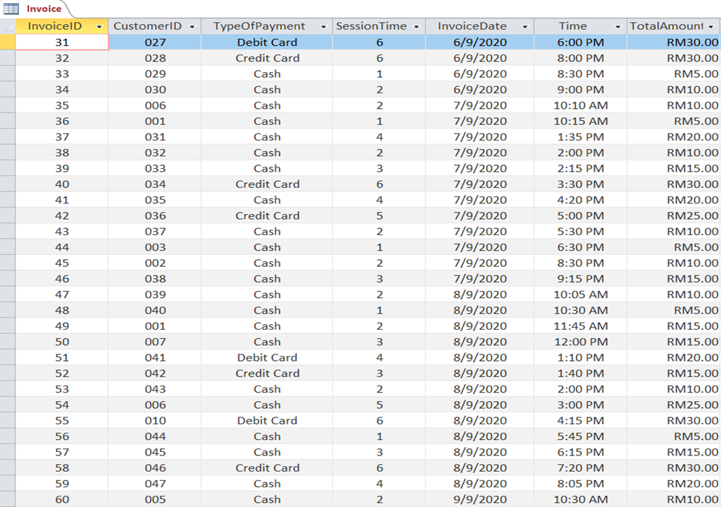**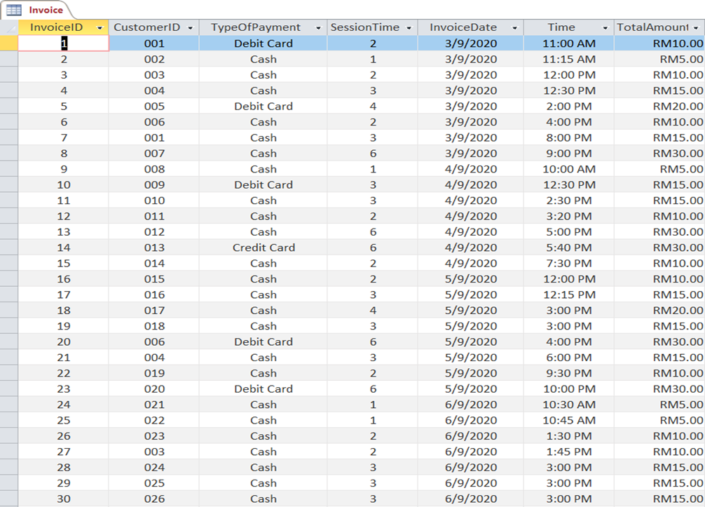Invoice**

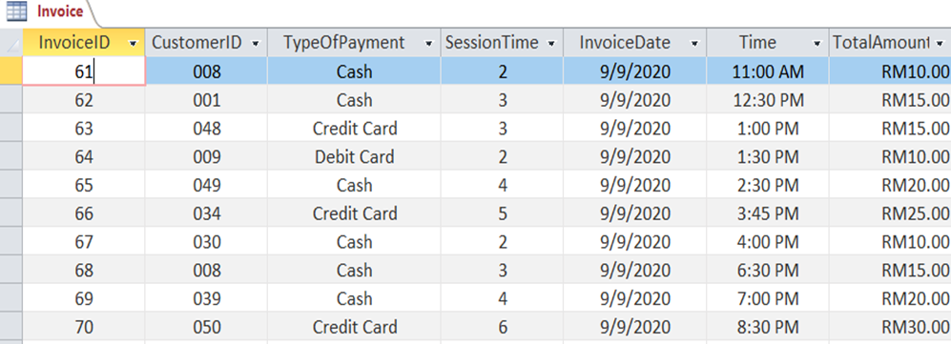

3.2: ESTABLISHING THE RELATIONSHIP

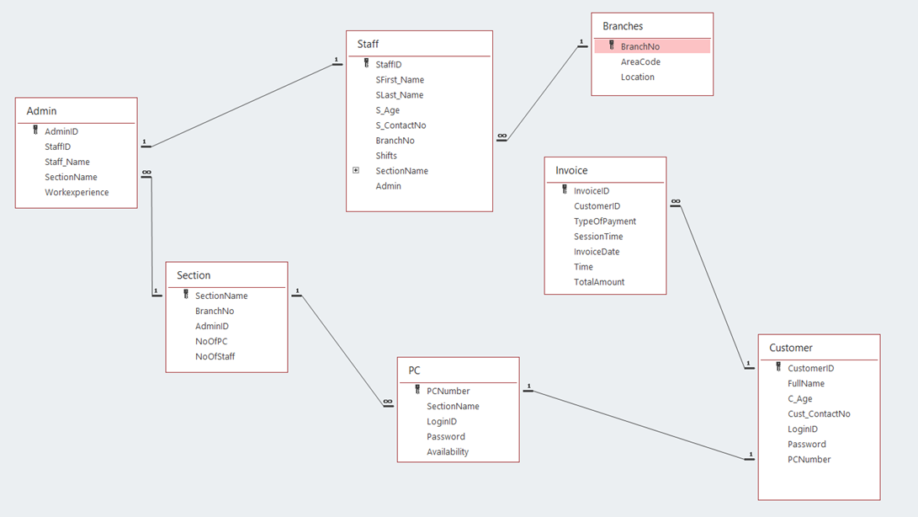

3.3: CREATE FORMS

**ADMIN APPLICATION FORM**

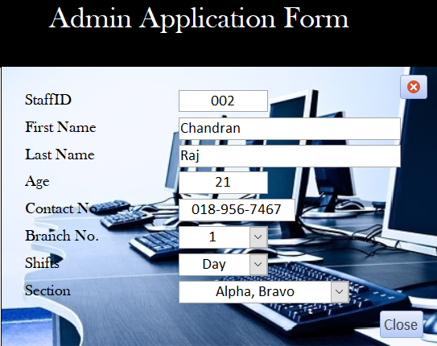

*TASK 4: Creating SQL Queries*

4.1: CREATE SQL QUERIES

* **COMPARISON OPERATOR**

|  |  |
| --- | --- |
| Query Purpose | The business is planning on implementing a senior citizen’s discount for the customers but would not know if it will be successful or not. This query’s purpose is to see which of the customers that would qualify for this discount. |
| SQL Commands | SELECT customerid, fullname, c_age, cust_contactno  FROM customer  WHERE c_age >54 |
| Output |  |

* **BETWEEN OPERATOR**

|  |  |
| --- | --- |
| Query Purpose | The business intends to open a knew branch in Penang, so it needs a very skilled and experienced admin to help manage the branch and guide the new staffs. The purpose of this query is to find suitable admins for this role. |
| SQL Commands | SELECT adminid, staff_name, sectionname, workexperience  FROM admin  WHERE workexperience between 4 and 6  ORDER BY workexperience DESC; |
| Output |  |

* **NULL, LOGICAL OPERATOR**

|  |  |
| --- | --- |
| Query Purpose | The purpose of this query is to find the details of customers who are currently using a computer in the cybercafe so it can be updated easily when they log out. |
| SQL Commands | SELECT customerid, fullname, loginid, password, pcnumber  FROM customer  WHERE loginid and pcnumber is not null  ORDER BY customerid; |
| Output |  |

* **COMPOUND CONDITIONS**

|  |  |
| --- | --- |
| Query Purpose | The purpose of the query is to quickly find available or unavailable PC’s based on their section and to update the PC availability accordingly. |
| SQL Commands | SELECT pcnumber, sectionname, loginid, password, availability  FROM pc  WHERE availability=[available/unavailable] and sectionname=[section]  ORDER BY pcnumber; |
| Output | EX: when availability==available, sectionname==bravo  EX: when availability==unavailable, sectionname==foxtrot |

* **CALCULATION, GROUP BY**

|  |  |
| --- | --- |
| Query Purpose | The purpose of this query is to calculate the average amount of money spent by each customer that visits the cybercafe |
| SQL Commands | SELECT DISTINCT Customerid, Avg(totalamount) AS Average_money_spent  FROM invoice  group by customerid |
| Output |  |

* **ORDER BY**

|  |  |
| --- | --- |
| Query Purpose | The purpose of this query is to find the details of staff working in a certain branch. |
| SQL Commands | SELECT staffid, sfirst_name&' '&slast_name AS staff_name, shifts, sectionname, branchno  FROM staff  WHERE BranchNo= Branch  ORDER BY staffid; |
| Output | E X: Branch==1    EX: Branch==4 |

*TASK 5: Contribution Evaluation*

|  |  |
| --- | --- |
| **Task** | **Contributors** |
| Creating a scenario for the Database Management System | Daniel Alexander, Hoo Kai Seng,  Lew Kai Ern, Lester Koon |
| Introduction | Hoo Kai Seng, Lester Koon |
| Finding and creating Business rules and relationships | Hoo Kai Seng, Lew Kai Ern |
| Identifying and classifying Entities and Attributes | Daniel Alexander, Hoo Kai Seng,  Lew Kai Ern |
| Designing and drawing an Entity Relationship Diagram | Daniel Alexander, Lester Koon |
| Establishing relationships between entities and identifying primary and foreign keys | Lew Kai Ern, Lester Koon |
| Creating a Data Dictionary | Daniel Alexander, Hoo Kai Seng, |
| Creating Tables in the database | Daniel Alexander, Hoo Kai Seng,  Lew Kai Ern, Lester Koon |
| Populating Tables in the database | Daniel Alexander, Lew Kai Ern |
| Establishing the Relationship between tables | Daniel Alexander, Lester Koon |
| Creating a form | Lew Kai Ern, Lester Koon |
| Creating SQL queries | Daniel Alexander, Hoo Kai Seng, |
| Documenting SQL queries | Daniel Alexander |
| Documenting and Checking the Group Project | Daniel Alexander, Hoo Kai Seng,  Lew Kai Ern, Lester Koon |